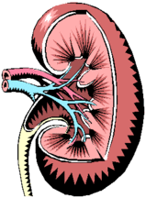 Transplant Staff Contact Numbers 

Kidney

**On Call Kidney Phone Number – 214-608-3621**

Inpatient Transplant Coordinator
Aldo Villagomez 214-846-5905

Liver

**On Call Liver Phone Number – 214-629-4062**

Inpatient Transplant Coordinator
Mireille Tanoh (MiMi) 214-846-2281

Advanced Practice Providers
Ivonne Grabow, PA
Lauren Redd, PA
Cindy Robertson Hugh, NP
Whitney Rodriguez, PA
Anne Ward, PA
Karen Warren, PA
Please refer to Inpatient APP schedule for APP on call

Social Workers
**On Call SW Phone Number – 214-490-9555**

Inpatient Social Worker – 214-933-7177
Nicole Adams
Melissa Martinez
Adelia Rice
Jacole Harp
Lauren Guajardo

Dietitians
Bethany Carrasco 214-947-4412
Jordyn Hauser 214-947-4413

